HP OpenView Smart Plug-In For ASAP
Reference Guide

Version 1.0

September 15, 2004



1 Introduction To The OpenView Smart Plug-In For ASAP 1-1
1.1 Overview 1-1
1.2 ASAP Data Within OpenView 1-2
1.2.1 The OpenView Services Tree 1-2
1.2.2 The OpenView Nodes Tree 1-3
1.2.3 The OpenView Message Browser 1-5
1.2.4 OpenView And OEM State Models 1-6
2 Installing The OpenView SPI For ASAP 2-1
2.1 System Requirements 2-1
2.1.1 Hardware Requirements 2-1
2.1.2 Software Requirements 2-1
2.2 Installation Procedure 2-1
2.2.1 Installation - Automated 2-2
2.2.2 Installation - Manual 2-2
2.3 Verifying The Installation 2-4
2.4 Files Installed 2-6
3 Removing The OpenView SPI For ASAP 3-1
3.1 Policy Removal Procedure 3-1
3.2 Adapter Removal Procedure 3-2
3.2.1 Removal - Automated 3-2
3.2.2 Removal - Manual 3-2
3.3 Files Removed 3-3
4 Configuring the ASAP OpenView Adapter 4-1
4.1 OEM Gateway Adapter Configuration 4-1
4.2 Accessing the ASAP OpenView Adapter Configuration Dialog 4-3
4.3 OVO Options 4-5
4.3.1 Service And Node Updates 4-6
4.3.2 Manually Updating/Reloading OpenView Data 4-7
4.3.3 Service Population Scheme 4-8
4.3.4 Deleting Services And Nodes From OpenView 4-12
4.3.5 Messaging Options 4-12
4.3.6 Utility Files 4-14
4.4 Logging Options 4-14
4.4.1 Enabling/Disabling Logging 4-15
4.4.2 Logging Level 4-15
4.4.3 Log File Name 4-16
4.4.4 Deleting The Log File 4-16
4.5 Tracing Options 4-16
4.5.1 Enabling/Disabling Tracing 4-17
4.5.2 Trace Items 4-17
4.5.3 Trace File Name 4-19
4.5.4 Record Limit 4-19
4.5.5 Wrapping Trace Data 4-19
4.6 Version Information 4-19
4.6.1 OpenView Adapter Version Data 4-20
4.6.2 Statistics 4-20
4.7 Command Line Options 4-20

Introduction To The OpenView Smart Plug-In For ASAP
The HP OpenView Smart Plug-in (SPI) for ASAP is a Microsoft Windows-based component that acts as an interface between the HP Open Enterprise Management Gateway (OEM) and HP OpenView Operations for Windows. Its purpose is to integrate ASAP state and performance data into an OpenView management environment.

Overview
The OpenView SPI for ASAP consists of two main components:

- The ASAP OpenView Adapter, which is a software agent responsible for routing ASAP data from the OEM into OpenView.
- An ASAP OpenView policy, which is added to OpenView and interprets and manages ASAP data within OpenView itself.

The basic mechanism for communicating data between ASAP and OpenView works as follows:

- The ASAP NonStop server-based components continually gather state and performance data on both application and system objects.
- This data is sent, on an ongoing basis, to the Windows-based ASAP Client application, which is responsible for displaying the information to the user and performing additional analysis functions.
- Once the ASAP Client has completed its analysis functions, information on all monitored NSK objects and their states is sent to the OEM.
- The OEM aggregates and normalizes this data, and routes the results to the ASAP OpenView Adapter.
- The Adapter examines the data to determine if it is necessary to update any OpenView data; if so, the relevant changes are sent to OpenView.
- The ASAP OpenView policy within OpenView interprets the changes and updates OpenView data accordingly.

The following diagram depicts the architecture of this environment:

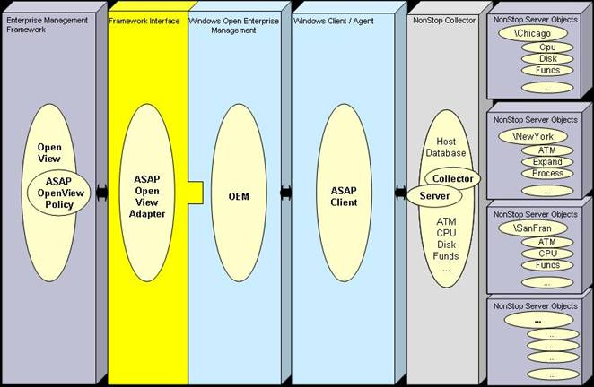

ASAP Data Within OpenView
Whenever the OpenView SPI for ASAP receives new ASAP data, it updates OpenView as necessary. These updates can potentially occur in three different areas of OpenView itself – the Services tree, the Nodes tree, and/or the Message Browser.

The OpenView Services Tree
ASAP data is added to the OpenView Services tree whenever you begin monitoring a new set of NSK objects (e.g. you start monitoring a new subsystem such as RDF or the Spooler, you add new application domains via ASAPX, or you add a new node to your ASAP configuration). All ASAP data in the Services tree resides under “HP NonStop Servers (ASAP)” in the “System Infrastructure” category of services.

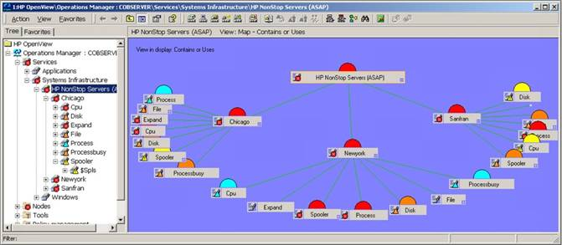

The level of detail added to the tree depends upon how you have the Adapter configured; choices range from adding nothing to adding every monitored NSK object. (See the Service Population Scheme description in section 4 for more details on how to configure this option.) Regardless of how much detail you add, though, the data is always organized in a hierarchical fashion. The level immediately below “HP NonStop Servers (ASAP)” contains a list of monitored NSK systems. Each of those systems can contain a list of monitored service types; these include system services such as CPU, Disk, and TMF, as well as application services monitored via the ASAPX product. And each of those service types can contain a list of sub-services, each of which can contain a list of its sub-services, etc., to any level of detail. This organization makes it easy to categorize and view NSK objects.

ASAP object state information is automatically propagated within the OpenView Services tree. This allows you to quickly determine, at a high level, the state of all services in your NSK network. Once you have detected a problem, you can drill down through the hierarchy to find which object(s) are reporting the error. And as you drill down, the OpenView Message Browser will reflect only those messages reported against the currently-selected object, saving you the trouble of searching through potentially hundreds of messages to find the one message you are interested in.

The OpenView Nodes Tree
The OpenView SPI for ASAP adds a list of all monitored NSK systems to the OpenView Nodes tree, in the “HP NonStop Servers (ASAP)” folder. As you add new NSK systems and begin monitoring them, they will be automatically added to the tree as well.

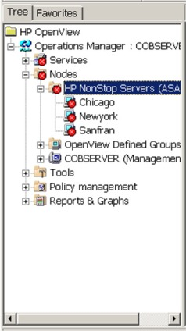

Unlike the Services view, the Nodes view does not contain a list of services on each system. However, you can still view all messages for objects on a given system by selecting that system in the Nodes tree. In addition, the Nodes tree is also shown in the OpenView web browser interface. This allows you to view ASAP data from any web browser on your network.

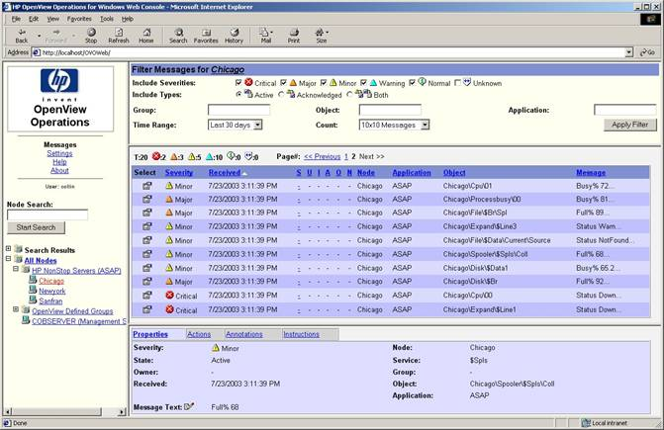

The OpenView Message Browser
The OpenView Message Browser contains a list of messages logged against objects managed via OpenView. The OpenView SPI for ASAP utilizes this facility to notify you whenever a monitored NSK object changes state (e.g. a CPU getting busy, a line handler being brought up, or an ATM running low on cash) by logging a message against that object. The details of the message include the name of the object, the service it is part of, the node it resides on, a severity level, and text describing the specific error.

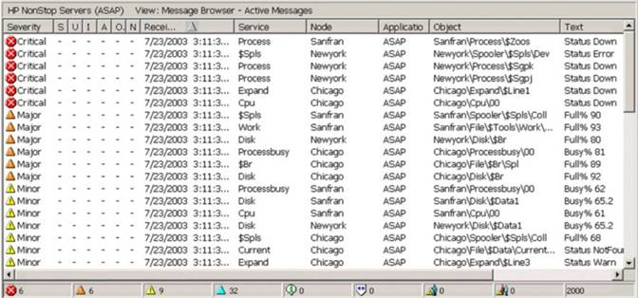

As you select a particular NSK node in the Nodes tree, or an NSK service in the Services tree, the Browser will update to show messages relevant to the selected object only. For example, the following shows the contents of the Message Browser with the service “CPU”, on system “\Chicago”, selected:

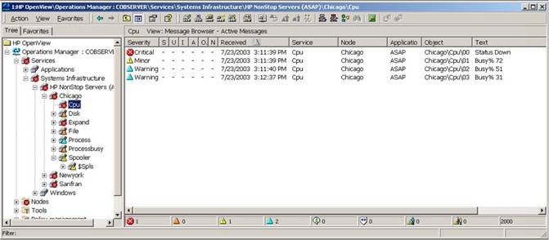

In addition, all standard OpenView features are available for messages posted against NSK objects: you can acknowledge a message, assign an owner, add notes, etc.

OpenView And OEM State Models

The ASAP Open Enterprise Management Gateway (OEM) allows any one of nine different states to be assigned to an object that is added to its configuration. However, OpenView utilizes a five state model. Thus, in addition to its other duties, the ASAP OpenView Adapter also maps OEM states to OpenView states when it logs a message against a particular object. This mapping is defined by the following table; note that it is ordered from least to most severe:

OEM Numeric State | OEM State Description | OpenView State
1 | Exists, no state information known | Normal
2 | Up or OK | Normal
3 | Low Usage | Warning
4 | Medium Usage | Warning
5 | High Usage | Warning
6 | Warning | Minor
7 | Critical | Major
8 | Down | Critical
9 | State Degradation | Critical

OEM and OpenView each utilize distinct state models, which means that OEM states cannot simply be passed through to OpenView. The Adapter addresses this issue by automatically mapping a given OEM numeric state to the OpenView state of closest corresponding severity whenever it posts a message against an object.

Installing The OpenView SPI For ASAP
The OpenView SPI for ASAP consists of two components: the ASAP OpenView Adapter and an ASAP OpenView policy. The Adapter runs on the OpenView server as a standalone process, while the policy is installed into OpenView itself. Both components must be installed in order for the SPI to function as intended.

System Requirements

Hardware Requirements
The OpenView SPI for ASAP runs on the OpenView server, thus its hardware requirements are identical to those of OpenView. Please consult the documentation for your version of OpenView to determine what hardware resources are necessary to run OpenView in your environment.

Software Requirements
In order to run the OpenView SPI for ASAP on your OpenView server, the following software must be installed on the server:

- Microsoft Windows 2000 Server or Windows 2003 Server
- HP OpenView Operations for Windows version 7.x
- ASAP Client, any version
- ASAP Open Enterprise Management Gateway (OEM), any version

In addition to the above, OpenView itself may require additional software components. Please see the documentation for your version of OpenView to determine if any such requirements exist.

Installation Procedure
The procedure for installing the SPI for ASAP on your OpenView server varies depending upon the method used for the installation. There are two different mechanisms available for you to use to accomplish this task: automated installation or manual installation. Regardless of the method used, though, the software requirements above must be met. So even if you install the SPI using the manual setup, you still must have the ASAP Client, OEM, and other components installed on the server in order to use the SPI.

Note that the SPI for ASAP installation utilizes portions of OpenView in order to load the SPI policy into the OpenView environment. This means that the ASAP OpenView policy cannot be installed if OpenView is not present on the server. For that reason, you should perform the SPI installation after you have installed OpenView. If for some reason you cannot do so, then once you do install OpenView on the server you will need to either re-install the SPI, or else manually install the policy (see the Manual installation section below for information on how to do so).

Installation - Automated
The preferred method for installing the SPI for ASAP is to use the automated setup wizard. This wizard will prompt you for all necessary information, and will then install the SPI for ASAP components automatically.

To perform an automated installation of the SPI for ASAP:

- Open Windows Explorer.
- Launch the SPI for ASAP automated setup wizard.
  - If you are installing from the SPI for ASAP CD, navigate to the CD drive (e.g. D:\), and double-click Setup.exe.
  - If you are installing a downloaded version of the SPI, navigate to the folder where you saved the downloaded file, and double-click SPIForASAPSetup.exe.
  - If you have previously installed the ASAP Client version 2.5 or later, navigate to the ASAPOpenViewSetup folder contained in the ASAP Client’s main installation path. Typically this would be the “Tandem\ASAPOpenViewSetup” folder within your program-files folder (e.g. “C:\Program Files\Tandem\ASAPOpenViewSetup”), but it may be different if the ASAP Client’s installation location was changed. Once you have navigated to the correct folder, double-click SPIForASAPSetup.exe.
- Follow the on-screen instructions to complete the installation.
- Verify that all components were installed correctly using the steps described in Verifying The Installation below.

Installation - Manual
If none of the automated means described above are available to you, you can install the SPI for ASAP on your server manually. This might be the case if, for example, you need to repair the SPI installation because it has become corrupted in some way. Rather than attempting to remove and reinstall the SPI, you can simply repair the SPI installation itself. To do so, you need to have access to the SPI component files OVOAdapter.exe, OVOAdapter.chm, OVOAdapter.ico, HHActiveX.dll, HP OpenView Smart Plug-In For ASAP Reference Guide.doc, HP OpenView Smart Plug-In For ASAP Reference Guide.pdf, ReadMe.txt, ASAP.mm, and ASAP-opcmsg.policy. These files were installed as part of any prior setup, and are also located on the SPI for ASAP CD. In addition, you must have access to the OpenView utility program ovpmutil.exe. Typically this is installed into the HP OpenView “bin” folder (e.g. “C:\Program Files\HP OpenView\bin”), and this folder is automatically added to the Windows search path. However, if ovpmutil.exe is not present, or the path has not been set correctly, you will need to obtain the utility and provide its fully-qualified path name in the steps below.

To install the SPI manually (or to repair a previous installation):

- Copy the Adapter component files OVOAdapter.exe, OVOAdapter.chm, OVOAdapter.ico, HP OpenView Smart Plug-In For ASAP Reference Guide.doc, HP OpenView Smart Plug-In For ASAP Reference Guide.pdf, and ReadMe.txt to the destination program folder on the server. Typically this would be the “Tandem\SPI for ASAP” folder within your program-files folder (e.g. “C:\Program Files\Tandem\SPI for ASAP”), but it can be any folder you choose.
- Create a folder within the destination folder above named “Policy” (e.g. “C:\Program Files\Tandem\SPI for ASAP\Policy”).
- Copy the SPI policy files ASAP.mm and ASAP-opcmsg.policy to the new folder.
- Copy the file HHActiveX.dll to the Windows\System32 folder (e.g. C:\Windows\System32).
- Register the Adapter. To do so, open a Command Prompt window and navigate to the destination folder from step 1 above (e.g. CD “C:\Program Files\Tandem\SPI for ASAP”). Then enter:
OVOAdapter –RegServerStatus
and press the Enter key. You will see a dialog confirming that the Adapter has been registered:

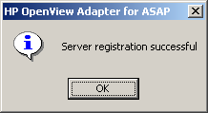

- Load the SPI policy into OpenView. To do so, using the Command Prompt window from above, enter:
ovpmutil cfg pol upl “Policy\ASAP.mm”
and press the Enter key (note that the quotes are required in the command). You will see the following confirmation message indicating that the policy has successfully been uploaded to OpenView:
Pmad connected!
Done!
Operation completed successfully.

- Deploy the SPI policy on your server. To do so, using the Command Prompt window from above, enter:
ovpmutil dep /p “\SPI for ASAP\ASAP-opcmsg” /n your-server-name-within-OpenView
and press the Enter key (note that the quotes are required in the command). This command requires you to supply the OpenView name of your server; in most cases this is the name of the server machine followed by “(Management Server)”, for example “OVOServ1 (Management Server)”. To obtain the name, start an OpenView Console and locate your server in the Nodes tree. This name is the name that must be supplied in this step; for example:
ovpmutil dep /p “\SPI for ASAP\ASAP-opcmsg” /n “OVOServ1 (Management Server)”
When the operation is complete, you will see the following confirmation message from OpenView:
Pmad connected!
Deploying Ver: "1.0" Type:"Open Message Interface"

- Register the HHActiveX.dll file. To do so, using the Command Prompt window from above, navigate to the Windows\System32 folder (e.g. CD C:\Windows\System32), and enter:
regsvr32 HHActiveX.dll
and press the Enter key. You will see a dialog confirming that the DLL has been registered.
- Verify that all components were installed correctly using the steps described in Verifying The Installation below.

Verifying The Installation
Once you have completed the installation of the OpenView SPI for ASAP, you can confirm that each component was installed correctly using the following steps:

- Ensure that all files are in the correct locations; see the Files Installed section below for the list of files and locations.
- Check the Adapter registration. To do so, open a Command Prompt window and navigate to the folder where you installed the SPI (e.g. CD “C:\Program Files\Tandem\SPI for ASAP”). Then enter:
OVOAdapter –CheckReg
and press the Enter key. If the Adapter is correctly registered on the server, you will see the following dialog:

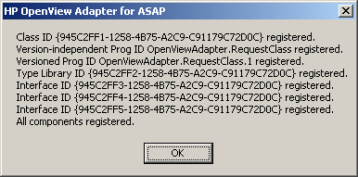

If there is a problem with the registration, the dialog will indicate which portions are incorrect. The following dialog shows a registration in which all portions are incomplete:

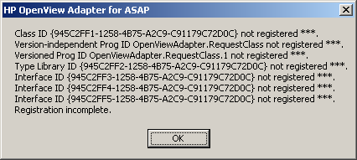

To correct registration problems, re-register the Adapter. See step 5 in the Manual installation section above for details on how to perform the registration.
- Verify that the SPI policy has been loaded correctly. To do so, start an OpenView Console and expand the “Policy management” folder in the tree. Then expand the “Policy groups” folder, and ensure that the “SPI for ASAP” policy folder is present:

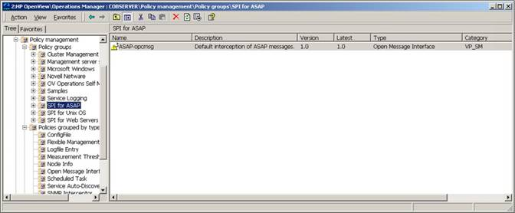

- Verify that the SPI policy has been deployed correctly. To do so, select the ”SPI for ASAP” policy folder described above.
In the right pane of the Console window, right-click on the “ASAP-opcmsg” policy and choose “All Tasks…Deploy on”. The “Deploy policies on…” dialog will appear. The box next to your OpenView server should be checked, indicating that the policy is deployed on the server:

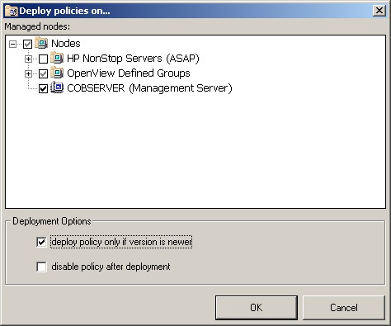

If all of the above are correct, then the OpenView SPI for ASAP has been completely installed on your server.

Files Installed
Regardless of which installation method was chosen, the same set of files is installed to the OpenView server. These are:

File Name | Installed To
HP OpenView Smart Plug-In For ASAP Reference Guide.doc | Program directory
HP OpenView Smart Plug-In For ASAP Reference Guide.pdf | Program directory
OVOAdapter.chm | Program directory
OVOAdapter.exe | Program directory
OVOAdapter.ico | Program directory
ReadMe.txt | Program directory
ASAP.mm | Program directory\Policy
ASAP-opcmsg.policy | Program directory\Policy
HHActiveX.dll | Windows\System32 directory

Removing The OpenView SPI For ASAP
At some point you may wish to remove the OpenView SPI for ASAP from your server machine. This requires removing both the ASAP OpenView Adapter and the ASAP OpenView policy. To do so, follow the steps outlined in the following sections. Note that you can remove either of the components first; the order does not matter.

Policy Removal Procedure
You must remove the ASAP OpenView policy from your OpenView environment via the OpenView Console. This essentially consists of two steps: one step to uninstall the policy from the active OpenView environment, and a second step to actually delete the policy files from the server. To remove the policy:

- Start an OpenView Console and expand the “Policy management” folder.
- Expand the “Policies grouped by type” folder, and select the “Open Message Interface” item in the tree.
- Uninstall the policy from the server. In the right pane of the Console window, right-click on the “ASAP-opcmsg” policy and choose “All Tasks…Uninstall from…”. The “Uninstall policies on…” dialog will appear. Check the box next to your OpenView server to indicate that the policy should be uninstalled from that system. Then click the OK button to uninstall the policy from your server:
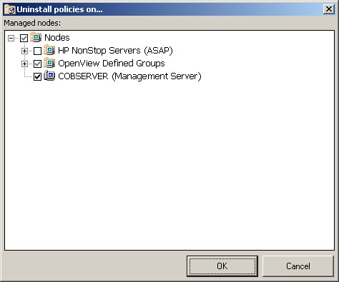

- Delete the policy from the server. Again in the right pane of the Console window, right-click on the “ASAP-opcmsg” policy, but this time choose “All Tasks…Delete from server”. This will remove the policy from the server.

Adapter Removal Procedure
The method you use to remove the ASAP OpenView Adapter from your OpenView server varies depending upon the method used to originally install the SPI for ASAP. In general you always want to use the removal procedure that corresponds to the initial installation procedure.

Removal - Automated
If you installed the Adapter using the automated setup wizard, you can remove it using the standard Windows Add/Remove Programs facility:

- On your server machine, click the “Start” button and choose “Control Panel”. The “Control Panel” window will open.
- In the “Control Panel” window, double-click “Add/Remove Programs”; this will open the “Add/Remove Programs” dialog.
- In the “Add/Remove Programs” dialog, locate the “HP OpenView SPI for ASAP” item in the “Currently installed programs” list, select it, and click the “Remove” button.
The ASAP OpenView Adapter will be removed from the server.

Removal - Manual
If you cannot remove the ASAP OpenView Adapter using the mechanism described above, you can do so manually. This might be the case if, for example, you initially installed the ASAP OpenView Adapter using the manual installation method.

To manually remove the Adapter:

- Delete Adapter configuration information. This is an optional step; if you are removing the Adapter but plan to reinstall it at some point, and wish to retain any user-configured Adapter options, then skip to step 2. If you do not plan to reinstall, or do not want to retain user-configured option settings, then open a Command Prompt window and navigate to the Adapter program folder (e.g. CD “C:\Program Files\Tandem\SPI for ASAP”). Then enter:
OVOAdapter –CleanRegStatus
and press the Enter key. This will remove all configuration data from the system, and will display the following message when complete:
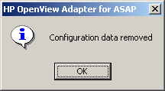

- Delete Adapter registration information. To do so, using the Command Prompt window from above, enter:
OVOAdapter –UnRegServerStatus
and press the Enter key. This will remove all Adapter registration information from the system, and will display the following message when complete:

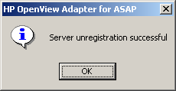

- Delete HHActiveX.dll file registration information and the HHActiveX.dll file (note that this is a shared file that could be used by other applications, so continue with this step only if you are certain no other applications require it. If you are unsure, skip to step 4.) To do so, using the Command Prompt window from above, navigate to the Windows\System32 folder (e.g. C:\Windows\System32), and enter:
regsvr32 /u HHActiveX.dll
and press the Enter key. You will see a dialog confirming that the registration information for the DLL has been removed. Then delete the HHActiveX.dll file itself.
- Delete Adapter files. To do so, exit the Command Prompt window from above, and from Windows Explorer, etc., remove the Adapter program folder (e.g. “C:\Program Files\Tandem\SPI for ASAP”) from the system.

Files Removed
Not surprisingly, the list of files removed from the server exactly matches those installed:

File Name | Removed From
HP OpenView Smart Plug-In For ASAP Reference Guide.doc | Program directory
HP OpenView Smart Plug-In For ASAP Reference Guide.pdf | Program directory
OVOAdapter.chm | Program directory
OVOAdapter.exe | Program directory
OVOAdapter.ico | Program directory
ReadMe.txt | Program directory
ASAP.mm | Program directory\Policy
ASAP-opcmsg.policy | Program directory\Policy
HHActiveX.dll | Windows\System32 directory

Configuring the ASAP OpenView Adapter
Once you have installed the HP OpenView SPI for ASAP on your OpenView server, you need to activate the ASAP OpenView Adapter within the OEM in order to utilize it. In addition, you may also wish to tailor exactly how the Adapter interacts with your OpenView environment. The following sections describe how to activate and configure the Adapter.

OEM Gateway Adapter Configuration
The ASAP subsystem furnishes data to the ASAP OpenView Adapter, and thereby to OpenView, through the ASAP Open Enterprise Management Gateway (OEM). In order for the OEM to send data to the Adapter, you must first activate the Adapter within the OEM’s configuration:

- On your OpenView server, start the ASAP Client.
- From the Client’s main window, click on View…Options. The “ASAP Properties” dialog will appear.
- Click on the “OEM” tab of the dialog.
- Check the “Open Enterprise Management” check box if it is not already checked:

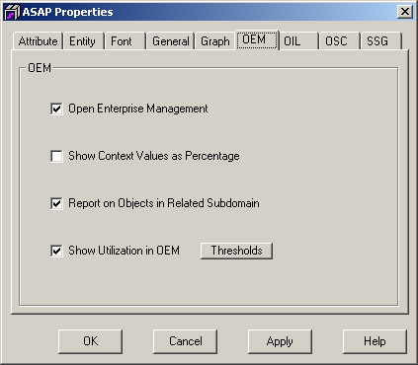

- Click the “OK” button to save the change and close the dialog.
- At this point, the OEM icon should be visible in the system tray of the server (i.e. next to the time):

- Double-click on the OEM icon to display the “OEM Options” dialog.
- Click on the “Adapters” tab of the dialog; this tab contains a list of all defined adapters, and their current states:

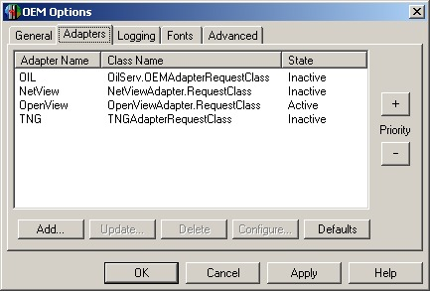

- Determine if the OpenView adapter is already correctly defined on your system. This will be the case if an entry exists in the list with an “Adapter Name” of “OpenView”, and a “Class Name” of “OpenViewAdapter.RequestClass”.
- If the OpenView adapter is defined on your system, double-click that entry in the list to bring up the “OEM Server: Update Adapter” dialog. Activate the adapter by choosing “Yes” next to the “Active?” item, and click the “OK” button:

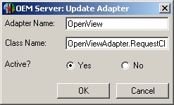

- If the OpenView adapter is not defined on your system, click the “Add…” button on the “Adapters” tab to add a new adapter. The “OEM Server: Add Adapter” dialog will appear. In the “Adapter Name” field, enter “OpenView” (without quotes). In the “Class Name” field, enter “OpenViewAdapter.RequestClass” (again without quotes). Choose “Yes” next to the “Active?” item, and click the “OK” button to add the new adapter:

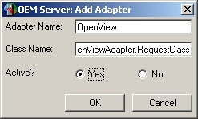

- Click the “OK” button on the “OEM Options” dialog to save these changes and close the dialog.
The ASAP OpenView Adapter is now active; the OEM will route any ASAP data to the Adapter.

Accessing the ASAP OpenView Adapter Configuration Dialog
The ASAP OpenView Adapter is an “invisible” component; it generally does not provide any kind of visual interface when it is running. You therefore access the Adapter’s configuration options through the OEM.

To view and/or change Adapter settings:

- Double-click on the OEM icon in the system tray to display the “OEM Options” dialog:

- Click on the “Adapters” tab of the dialog; this tab contains a list of all defined adapters, and their current states:

- Click on the “OpenView” entry in the list, and then click the “Configure…” button.
- The “HP OpenView Adapter For ASAP Options” dialog will appear. Make changes to any options you wish, as described in the following sections. Click the “Apply” button to save these changes and leave the dialog open, click the “OK” button to save the changes and close the dialog, or click the “Cancel” button to close the dialog without saving changes:

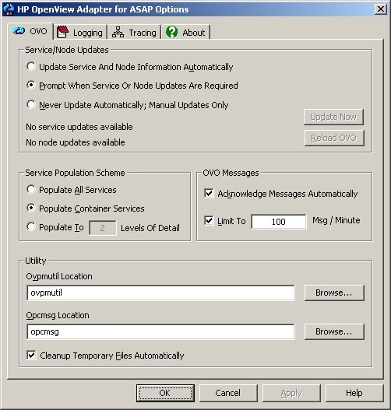

- Click the “OK” or “Cancel” button on the “OEM Options” dialog to close that dialog. Note that the ASAP OpenView Adapter settings are saved separately from the OEM options; thus it is not necessary to choose “OK” or “Apply” on the “OEM Options” dialog in order to save Adapter settings. Once you have clicked “OK” or “Apply” on the “HP OpenView Adapter For ASAP Options” dialog, all Adapter settings have been saved.

OVO Options
Once you have opened the “HP OpenView Adapter For ASAP Options” dialog as described above, click on the “OVO” tab to configure OpenView interface-related options. These include settings that dictate how the Adapter updates OpenView service and node information, how much detail gets populated into the OpenView Services tree, message limit and acknowledgement options, and utility file locations:

Service And Node Updates
The NonStop ASAP subsystem allows you to begin monitoring new objects at any time. These can be system objects such as CPUs and processes, or application-defined objects monitored using the ASAPX API. As these objects are added, information on them is sent to the ASAP Client, which in turn passes the data on to the ASAP OpenView Adapter. When the Adapter receives this data, it determines if new services or nodes have been added; if they have, then OpenView needs to be updated to include these items.

However, there can be issues with simply performing these updates as they occur, since the OpenView Console caches information from the OpenView server database. Thus new service/node information added to OpenView by the Adapter may not immediately appear in active OpenView Consoles, since those Consoles may be utilizing their cached data instead.

To prevent possible confusion as a result, and to give you better control over when OpenView service and node updates occur, the Adapter provides three different options for updating OpenView data, listed in the “Service/Node Updates” group on the “OVO” tab:

- Update Service And Node Information Automatically
If you choose this option, the ASAP OpenView Adapter will automatically update service and node information as needed, whenever it detects changes. When the Adapter does perform an update, a message will appear on the server informing you to restart any active OpenView Consoles in order to retrieve the latest changes.

- Prompt When Service Or Node Updates Are Required
If you choose this option, the ASAP OpenView Adapter will prompt you whenever it detects that service or node updates are necessary. If you choose to continue, the Adapter will add the new services and/or nodes to OpenView. You should then restart any active OpenView Consoles in order to ensure that you are running with the latest data. If you choose not to continue, the Adapter will not send the updates to OpenView. Instead, you can send them manually later as described in Manually Updating/Reloading OpenView Data. This is the default option.

- Never Update Automatically; Manual Updates Only
If you choose this option, the Adapter will never automatically update OpenView. Instead, you will have to manually update OpenView as needed, as described in Manually Updating/Reloading OpenView Data.

Manually Updating/Reloading OpenView Data
In addition to deciding how the Adapter should handle service and node updates, the “Service/Node Updates” group also allows you to manually update or reload OpenView data.

- Manually Updating Data
The “Service/Node Updates” group contains two status fields at the bottom of the group; these are used to inform you if service or node updates are available. If they are, and you wish to update OpenView, click the “Update Now” button to cause the Adapter to add the new service and node information to OpenView. Once the operation is complete, you should restart any active OpenView Consoles in order to retrieve the latest data.

- Reloading All Service And Node Data
In some cases you may wish to force the Adapter to re-send all service and node information to OpenView. This might occur if, for example, you inadvertently deleted some ASAP services from OpenView itself. To do so, click on the “Reload OVO” button; the Adapter will add all current service and node information to OpenView. In addition, note that the Adapter will also re-issue an OpenView message for each object in an error state. Again, once the operation is complete, you should restart any OpenView Consoles to ensure that you are running with the latest data.

Important: Note that OpenView service, node, and message updates could take a significant amount of time to complete in cases where many objects or messages are added to OpenView. It is not unusual for some updates to require several minutes before all data appears in the OpenView Console. Ordinarily, this scenario will only occur when the ASAP Client and ASAP OpenView Adapter are initially started, or after a manual reload of OpenView data, since in those instances the Adapter is potentially supplying a large amount of data to OpenView. However, the updates may also take longer to complete in the event you have a major outage within your NSK network (e.g. an entire system being taken off-line, etc.).

Service Population Scheme
ASAP data is added to the OpenView Services tree whenever you begin monitoring a new set of NSK objects (e.g. you start monitoring a new subsystem such as RDF or the Spooler, you add new application domains via ASAPX, or you add a new node to your ASAP configuration). All ASAP data in the Services tree resides under “HP NonStop Servers (ASAP)” in the “System Infrastructure” category of services. The level of detail that the ASAP OpenView Adapter adds to this tree depends upon the configured population scheme. Choices include populating all ASAP services, only populating those services that contain sub-services, or populating to a fixed depth in the hierarchy. These options are contained in the “Service Population Scheme” group on the “OVO” tab:

- Populate All Services
If you choose to populate all services, then all ASAP monitored objects will be added to the OpenView Services tree. For example, if ASAP is monitoring CPUs on system \Chicago, and that system contains four CPUs (00, 01, 02, and 03), the services “Chicago”, “Chicago\CPU”, “Chicago\CPU\00”, “Chicago\CPU\01”, “Chicago\CPU\02”, and “Chicago\CPU\03” will be added to the Services tree. The same would apply to all other entities and objects monitored by ASAP:

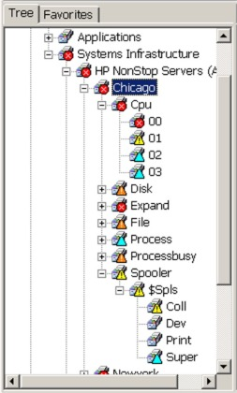

The advantage of populating all services is that it allows you to drill down to the NSK object level in order to retrieve state information. This also greatly simplifies OpenView message filtering, since as you drill down you will see only those messages that pertain to the selected object. However, there is a cost associated with this in terms of the number of services and objects added to OpenView. If you use ASAP to monitor a large network of systems and objects, it may not be feasible to populate all services/objects.

- Populate Container Services
This option specifies that only those services that contain sub-services should be added to the OpenView Services tree. In effect what this gives you is a tree containing true categories of services, while the actual objects that comprise those services are not present. Note that the number of levels in the resulting OpenView hierarchy could vary from service to service. For example, if ASAP is monitoring CPUs on \Chicago, the Adapter will add the services “Chicago” and “Chicago\CPU” to OpenView. If in addition ASAP is monitoring the Spooler $SPLS on \Chicago, the Adapter will also add the services “Chicago\Spooler” and “Chicago\Spooler\$SPLS”, because the $SPLS Spooler contains a set of sub-services such as its supervisor, collector, etc. Thus in this scenario the “Chicago\CPU” hierarchy would contain one less level of detail than the “Chicago\Spooler” hierarchy:

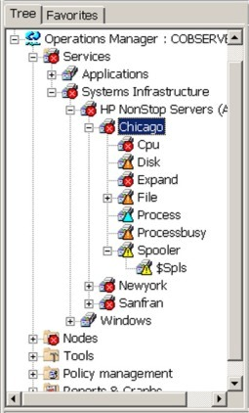

The advantage of this approach is that it provides a high level of detail on the state of various services, allowing you to drill down to determine exactly which service(s) are in an error state. At the same time, because each object monitored by ASAP is not added to the tree, the number of services in OpenView is greatly minimized, making it much easier to manage a large network of NSK systems. This is the default option.

- Populate To n Levels Of Detail
If you wish to more closely control the level of detail added to the OpenView Services tree, you can opt to populate services to a fixed depth. The value you supply here defines how many levels of services are to be added to the Services tree under “HP NonStop Servers (ASAP)”. When the Adapter adds service information to OpenView, it will stop adding levels of detail once this value is reached. The result is a very balanced hierarchy within OpenView. For example, if ASAP is monitoring CPUs and the Spooler $SPLS on system \Chicago, the Adapter will add the services “Chicago”, “Chicago\CPU”, and “Chicago\Spooler” to OpenView if you have specified a depth of 2:

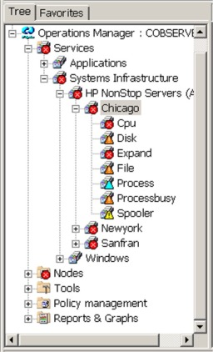

Note that the Adapter can only add levels of detail if such data exists. Therefore, if you were to specify a depth of 4, for example, the “Chicago\CPU” hierarchy would still only extend 3 levels (“Chicago\CPU\00”, “Chicago\CPU\01”, etc.) because there are no objects defined under the individual CPUs.

The Services Tree And OpenView Messages

It is important at this point to distinguish between the OpenView Services tree and the messages logged to OpenView by the ASAP OpenView Adapter. The main purpose of the Services tree is to categorize services and make it easier for you to determine, to whatever granularity you have configured, the state of the various services that comprise your network of NSK systems. The more levels of service detail you add to the tree, the better you can determine where problems exist in your NSK network, and the more quickly you can view messages related to those services.

However, the content of the Services tree has virtually no impact on the content of the messages that the Adapter logs to OpenView. The Adapter always logs messages against the actual low-level object that reported an error. Thus the “Object” column in the OpenView Message Browser will always contain the name of the specific object that caused that message to be generated, regardless of what level of detail exists in the Services tree. The only portion of message content that is influenced by the Services tree is the service against which a given message is logged; this is contained in the “Service” column in the Message Browser.

For example, assume that you have chosen to populate all container services. And assume further that you are monitoring CPUs on system \Chicago, and that CPU 00 is in a critical state. The ASAP OpenView Adapter would log a message to OpenView, with a severity of “Critical”, and specify the object “\Chicago\CPU\00”. Since you populated the Services tree with containers only, the message would be logged against service “CPU” on node “Chicago”:

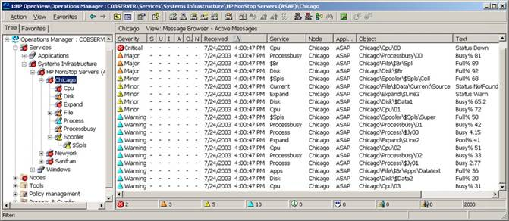

If instead you decided to populate the Services tree to 1 level of detail (i.e. NSK systems only), the message described above would be exactly the same, with the exception that it would be logged against the service “Chicago”, since there are no additional levels of services present in the tree. The message would still be generated for the object “Chicago\CPU\00”, as it was above:

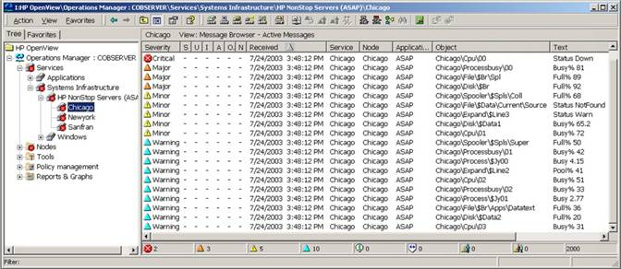

Deleting Services And Nodes From OpenView
The ASAP OpenView Adapter does not automatically remove any of the services or nodes that it has previously added to OpenView. Once a service or node has been added to the OpenView environment, messages can be logged against it, and that service or node becomes part of the OpenView configuration. This means that even if ASAP is no longer monitoring a given NSK object, you can still view the history of messages logged against that object within OpenView.

If at some point your ASAP configuration changes and you wish to delete one or more services or nodes from OpenView, you can do so using the OpenView Console. This might be necessary if, for example, you alter the Service Population Scheme in a way that reduces the number of levels of service detail added (e.g. you choose to now populate 1 level of detail, whereas previously you had populated 2 levels). Note, though, that removing a given service or node from the OpenView configuration will also remove any messages associated with that object.

Messaging Options
The ASAP OpenView Adapter logs a message whenever an ASAP-monitored object changes state. These messages are displayed in the OpenView Message Browser window. The details of each message include the name of the object, the service it is part of, the node it resides on, a severity level, and text describing the specific error or condition that caused the message.

Automatic Message Acknowledgement
As you would expect, the state of a given object can change many times while it is being monitored. Each of these state changes will cause the Adapter to log a new message to OpenView. When OpenView receives a message for an object that already has a message logged against it, it can proceed in one of two ways: it can add the new message to the list of messages logged against the object, or it can automatically acknowledge prior messages and only display the latest message in the active Message Browser. You can configure this behavior by checking/unchecking the “Acknowledge Messages Automatically” check box under “OVO Messages” on the “OVO” tab. To cause messages to be acknowledged automatically, and thereby only display the latest message for each object, check the box. To allow messages to accumulate for each object, uncheck the box. Note that you can still acknowledge any of the messages manually via the OpenView Console.

The following shows a sample of the contents of the Message Browser for the object “\Chicago\CPU\03” if you were to run with automatic acknowledgement disabled. The result is essentially the history of messages for the object. It is important to note that, in this scenario, the Services tree will reflect the state of the most critical unacknowledged message for the object, not the latest message:

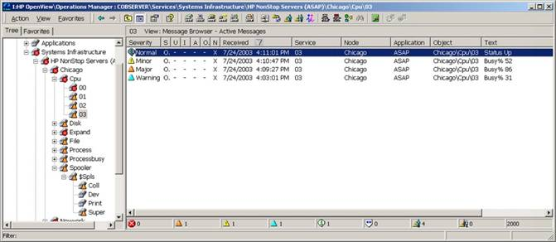

Automatic acknowledgement is enabled by default.

Limiting The Number Of Messages Logged
In some cases, for example an entire NSK system being taken off the network, hundreds or thousands of ASAP-monitored objects can change state in an instant. The number of messages logged by the ASAP OpenView Adapter as a result of this occurrence could have a significant impact on your OpenView server. To avoid this situation, you can choose to regulate the number of messages generated by the Adapter in a given interval. To do so, check the “Limit To n Msg / Minute” check box under “OVO Messages” on the “OVO” tab, and supply the maximum number of messages that should be logged per minute.

If this option is enabled, the Adapter will not exceed the specified limit during any one minute interval. Note, though, that the Adapter retains information on all monitored objects, and thus is able to “catch up”, if needed, as time goes by. It will continue to log the maximum number of messages per minute until messages have been logged for all necessary objects. In addition, the Adapter always logs messages in order from most severe to least severe. Thus the most critical messages will always be sent to OpenView first.

This option is enabled by default, with a message limit of 100 messages per minute.

Utility Files
As part of its normal operation, the ASAP OpenView Adapter requires access to the ovpmutil.exe and opcmsg.exe OpenView utility programs. They are used to add service and node data to OpenView, and also to route messages.

File Locations
Typically these utilities are located in the HP OpenView program directory (or one of its subdirectories), and those directories have been added to the Windows search path. In some cases, though, these files might reside in a different location, or the directories may not be on the Windows search path. If this occurs, you can specify the file locations manually. To do so, enter the full path and file name of the ovpmutil.exe file in the “Ovpmutil Location” field in the “Utility” group on the “OVO” tab, and enter the full path and file name of the opcmsg.exe file in the “Opcmsg Location” field. To locate and select the files interactively, click the “Browse…” buttons next to each of the respective fields.

Cleaning Up Temporary Files
In some cases, the utility programs generate temporary data files that are stored in the Adapter program directory. In general there is no reason to retain these files, and the Adapter automatically deletes them as necessary. However, at times you might find it useful to keep them, particularly if you are attempting to debug a problem. To specify whether the Adapter should automatically delete these temporary files, check/uncheck the “Cleanup Temporary Files Automatically” check box in the “Utility” group on the “OVO” tab. If you enable this option, the Adapter will automatically delete any temporary files. If you disable this option, the temporary files will remain the Adapter program directory. This option is enabled by default.

Logging Options
The ASAP OpenView Adapter provides a logging mechanism that is used to report run-time errors and Adapter state information. You can define which types of information should be logged (errors, warnings, etc.), and can also specify the log file name and location. To configure logging-related options, click on the “Logging” tab of the “HP OpenView Adapter For ASAP Options” dialog:

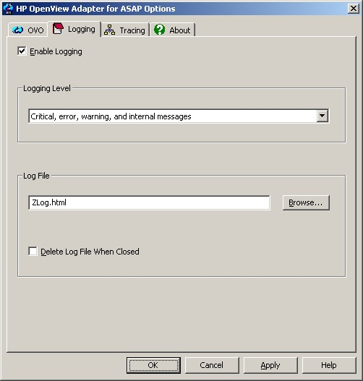

Enabling/Disabling Logging
To enable the Adapter logging facility, check the “Enable Logging” check box. To disable logging, uncheck the check box. Logging is disabled by default.

Logging Level
The logging level specifies which types of messages are logged by the Adapter. These types are:

Message Type | Description
Internal | Internal messages are generated from within the logging facility itself. If Logging is enabled, Internal messages are automatically enabled as well.
Critical | Critical messages are generated if the Adapter encounters a problem from which it cannot recover or which will prevent it from functioning correctly.
Error | Error messages are generated if the Adapter encounters a problem from which it can recover and continue to run, although potentially in degraded fashion.
Warning | Warning messages are generated if the Adapter encounters a problem from which it can recover and continue to run in a normal fashion.
Info | Info messages are generated to provide status information on operations performed by the Adapter.

To set which message types are logged, click the drop-down arrow under “Logging Level” on the “Logging” tab, and choose the appropriate option: Internal messages only; Critical and internal messages; Critical, error, and internal messages; Critical, error, warning, and internal messages; or All messages.

Log File Name
You can define the name and location of the log file used by the Adapter. By default this will be “Zlog.html”, located in the same directory as the Adapter program file. However, you can change the location and/or file name by entering a new value in the “Log File” field on the “Logging” tab. To locate and select the file interactively, click the “Browse…” button.

Deleting The Log File
If you run with logging enabled, the log file can potentially grow to be quite large over a long period of time. While you can always manually delete this file, the Adapter can also automatically delete the file whenever it is closed (as would be the case if you changed the log file name, or when the Adapter is shut down). This gives you access to the log data while the Adapter is running, but helps prevent the log file itself from growing too large.

To automatically delete log files whenever they are closed, check the “Delete Log File When Closed” check box on the “Logging” tab. To retain all log data, uncheck the check box. By default all data is retained.

Tracing Options
The ASAP OpenView Adapter provides a tracing facility that can be used to diagnose problems with the Adapter or with OpenView. You can define which types of information should be traced, can specify the trace file name and location, and can also limit the amount of trace data collected. To configure tracing-related options, click on the “Tracing” tab of the “HP OpenView Adapter For ASAP Options” dialog:

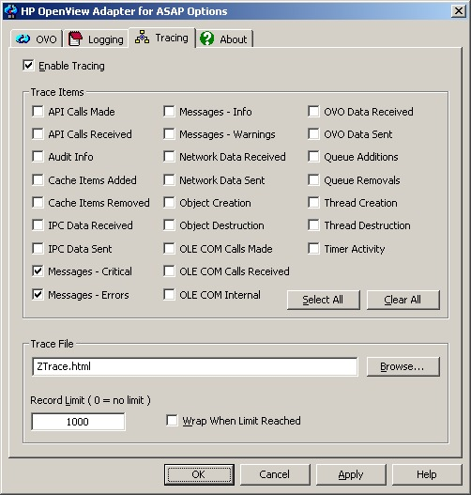

Enabling/Disabling Tracing
To enable the Adapter tracing facility, check the “Enable Tracing” check box. To disable tracing, uncheck the check box. Tracing is disabled by default.

Note that tracing can have a significant impact on the performance of the Adapter, and thus it should only be enabled if you are attempting to diagnose a problem. In general you should only activate tracing if you have been asked to do so by HP support staff. If you do enable tracing, you should also attempt to have it enabled for the minimum amount of time possible. Try to reproduce the problem scenario quickly, and then immediately disable tracing. Doing so has two advantages: first, it increases the likelihood that you will capture relevant trace information; and second, it limits the impact on the Adapter and your operations management environment.

Trace Items
The Adapter allows you to trace any combination of the following types of data:

Trace Item | Description
API Calls Made | COM API calls made by the Adapter
API Calls Received | COM API calls received by the Adapter
Audit Info | Various Adapter internal statistics and operations
Cache Items Added | Activity related to adding items to the Adapter’s object cache
Cache Items Removed | Activity related to removing items from the Adapter’s object cache
IPC Data Received | Data sent to the Adapter from another process
IPC Data Sent | Data sent by the Adapter to another process
Messages - Critical | Critical errors that occur during normal processing which prevent the Adapter from operating correctly
Messages - Errors | Errors that occur during normal processing from which the Adapter can recover and continue to run, although potentially in degraded fashion
Messages - Info | Informational messages generated during normal processing
Messages - Warnings | Errors that occur during normal processing from which the Adapter can recover and continue to run in a normal fashion
Network Data Received | Data received by the Adapter from a network client
Network Data Sent | Data sent by the Adapter to a network client
Object Creation | Internal objects created by the Adapter; tracing this item will have a severe impact on Adapter performance, and should only be enabled if diagnosing an object-related problem
Object Destruction | Internal objects destroyed by the Adapter; tracing this item will have a severe impact on Adapter performance, and should only be enabled if diagnosing an object-related problem
OLE COM Calls Made | OLE/COM calls made by the Adapter
OLE COM Calls Received | OLE/COM calls received by the Adapter
OLE COM Internal | OLE/COM internal activity within the Adapter
OVO Data Received | Data received from OpenView by the Adapter
OVO Data Sent | Data sent to OpenView by the Adapter
Queue Additions | Activity related to adding items to the Adapter’s internal queues
Queue Removals | Activity related to removing items from the Adapter’s internal queues
Thread Creation | Activity related to starting new threads within the Adapter
Thread Destruction | Activity related to threads ending within the Adapter
Timer Activity | Timer-based processing and status information; tracing this item could have a severe impact on Adapter performance, and should only be enabled if diagnosing a timing-related problem

To specify the items to trace, check the box corresponding to the item(s) you are interested in. To select all items, click the “Select All” button; to deselect all items, click the “Clear All” button.

Trace File Name
You can define the name and location of the trace file used by the Adapter. By default this will be “Ztrace.html”, located in the same directory as the Adapter program file. However, you can change the location and/or file name by entering a new value in the “Trace File” field on the “Tracing” tab. You can also click the “Browse…” button to locate and select the file interactively.

Note that no trace data is written to this file until tracing is disabled or until the Adapter shuts down.

Record Limit
Depending upon how long tracing is active and the number and types of trace items selected, trace data can accumulate very rapidly or very slowly. All trace data is collected in memory, and is only written to the trace file when tracing is disabled or when the Adapter shuts down.

To control how much trace data is collected, you can limit the number of trace records retained within the Adapter using the “Record Limit” field on the “Tracing” tab. Once this limit is reached, the Adapter will stop collecting trace data (unless wrapping is enabled; see Wrapping Trace Data below).

To specify a new record limit, enter the new value in the field. If you do not want the Adapter to impose a limit, enter 0 in this field. The default value is 1000 records.

Wrapping Trace Data
In most cases, you will not know ahead of time how many trace records will be needed in order to capture all the data related to a given problem. Instead, the usual scenario is that you run and test, and eventually the error occurs. Since in most cases you do not want to collect an unlimited number of trace records, the Adapter allows you to specify that trace data should automatically “wrap” whenever the record limit is reached. What this means is that, when the given record limit is reached, each subsequent new trace record replaces the oldest existing trace record. Thus you always end up with the most recent trace data, yet you can still control how much data is retained by the Adapter.

To enable wrapping, check the “Wrap When Limit Reached” check box on the “Tracing” tab. To disable wrapping (and thereby retain the oldest trace data), uncheck the check box. This option is disabled by default.

Version Information
Adapter version and statistics information are located on the “About” tab of the “HP OpenView Adapter For ASAP Options” dialog:

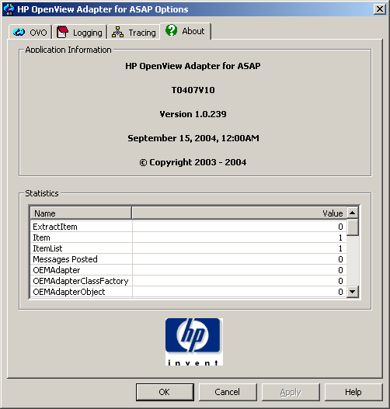

OpenView Adapter Version Data
The “Application Information” section contains the Adapter version number and date. This data will be needed by HP support staff in the event you need to report a problem with the Adapter.

Statistics
The “Statistics” section contains a variety of Adapter internal statistics used for debugging purposes; these may also be needed by HP support staff if a problem occurs with the Adapter.

Command Line Options
The ASAP OpenView Adapter can be run interactively with several different command-line options. In general the purpose of these options is to cause the Adapter to perform a configuration-related function and then exit. Note that in these cases this means that you cannot supply multiple command-line options, since the Adapter will exit before processing any subsequent options.

To run the Adapter with a command-line option, using the following syntax:

OVOAdapter –option
Where option is one of the following:

Option | Description
CheckReg | Validates Adapter registration information and displays a confirmation dialog listing any missing items. The Adapter exits immediately after processing this request.
CleanReg | Removes all Adapter user-configured options from the system Registry, but does not display a confirmation dialog. The Adapter exits immediately after processing this request.
CleanRegStatus | Removes all Adapter user-configured options from the system Registry and displays a confirmation dialog. The Adapter exits immediately after processing this request.
Configure | Displays the Adapter’s configuration options dialog, allowing you to change any Adapter settings. Once you close the dialog, the Adapter will prompt you to continue normal execution or exit.
Help | Displays a list of all valid command-line options. The Adapter exits immediately after processing this request.
RegServer | Registers the Adapter, but does not display a confirmation dialog. The Adapter exits immediately after processing this request.
RegServerStatus | Registers the Adapter and displays a confirmation dialog. The Adapter exits immediately after processing this request.
TraceMask value | Sets the Adapter’s trace mask to the supplied value, where value is a hexadecimal string corresponding to the trace mask. This is intended for debugging purposes only. The Adapter continues normal execution after processing this request.
UnRegServer | Removes registration information for the Adapter, but does not display a confirmation dialog. The Adapter exits immediately after processing this request.
UnRegServerStatus | Removes registration information for the Adapter and displays a confirmation dialog. The Adapter exits immediately after processing this request.

